1. Deepin Linux Original Installation

<http://wiki.deepin.org/index.php?title=Original_Installation>

* 1. Preface

This page will simply introduce the installation of deepin OS.

Video：[Tutorial on installation of deepin system(Deepin Boot Maker)](https://www.youtube.com/watch?v=1L7-EQUVDrI&feature=youtu.be)

* 1. Download Mirror

Linux requires low kernel operation, but deepin desktop environment still needs certain configuration in the following:

* Blank DVD or USB (over 2 GB)
* Processor: Intel Pentium IV 2GHz or much faster processor
* Memory: At least 2GB(RAM), more than 4G with the best performance
* Hard disk: At least 8 GB (only needed in installation)

Open [deepin download](http://www.linuxdeepin.com/download.cn.html) by browser and download deepin mirror file, please download the latest version to experience deepin newest functions.

32-bit is recommended in memory less than 2G and 64-bit is recommended in memory more than 2G.

**Note：64-bit can be installed only CPU supports x86-84 or AMD64 instruction set. You could use [[CPU-Z](https://en.wikipedia.org/wiki/CPU-Z)]（Windows）to view instruction set.**

Please download from source address for the right deepin mirror and test the MD5 value after downloaded. System may not be stable or installed due to wrong MD5 value.

* Windows System

Download [Hash](http://64.duote.org/hash.exe) to test the MD5 value

* Linux System

Open the mirror directory with cd under terminal and execute:

md5sum xxxx.iso ##(xxxx.iso is the mirror downloaded and autocompletion can be done with TAB key)

Note: [deepin download](http://www.linuxdeepin.com/download)MD5 value for all versions are available.

* 1. Make Startup Disk

deepin team has developed cross-platform startup disk maker, you can use it to make startup disk. deepin mirror has covered the startup disk maker.You can find it in deepin mirrror or [click for download](http://pan.baidu.com/disk/home" \l "from=share_pan_logo).

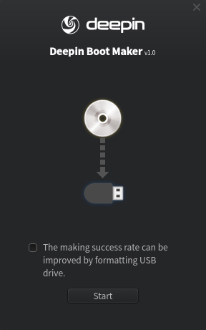

Open the software, insert USB to the computer and then select deepin mirror to make startup disk. USB can not be removed during this period and please restart your computer after finished.

**Caution: Please transfer the important data in USB in advance.**

* 1. Install deepin

**Note:**

* Please deactivate“quick boot” under windows 8, or the partition cannot be done.
* Please deactivate “Secure Boot” under UEFI mainboard.

Restart your computer and press the key of “Changing boot order”, which will appear in BIOS/UEFI interface.

press "Delete" for desktop

press "F2" for laptop

press "C" for APPLE computer

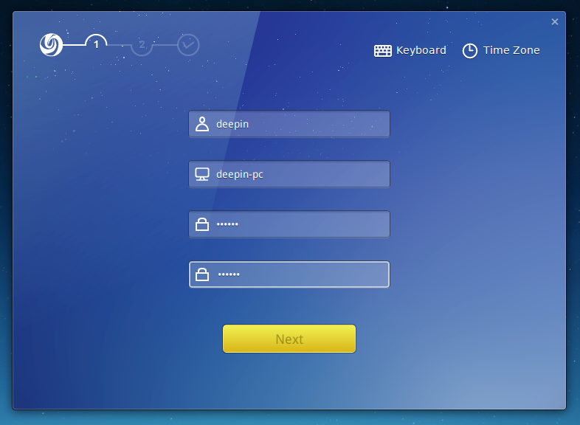

Choose USB as the first boot option and then enter into Live CD. We can simply experience deepin OS after entered. Click “install deepin” and open the deepin installer to install. Click NEXT STEP into the partition mode after simply filled user name and password.

* + 1. Simple Mode

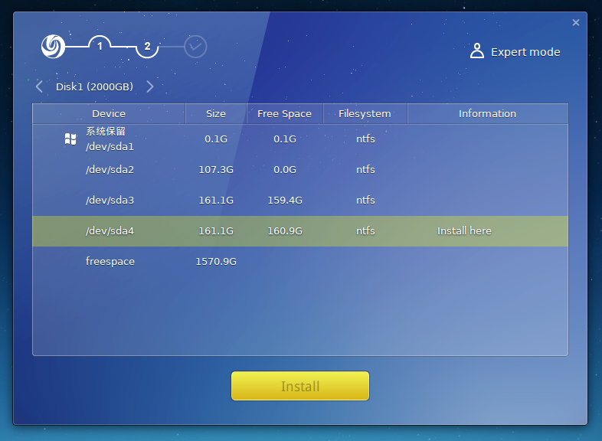

* If windows existed, please install deepin OS into one of its partitions. The installer will format the chosen partition, so please remember to transfer the data in advance. Dual system can be achieved in normal windows system disk (C disk ).
* Please create a new partition to install deepin OS after entered into expert mode if the current hard disk is a new one.

Expert Mode

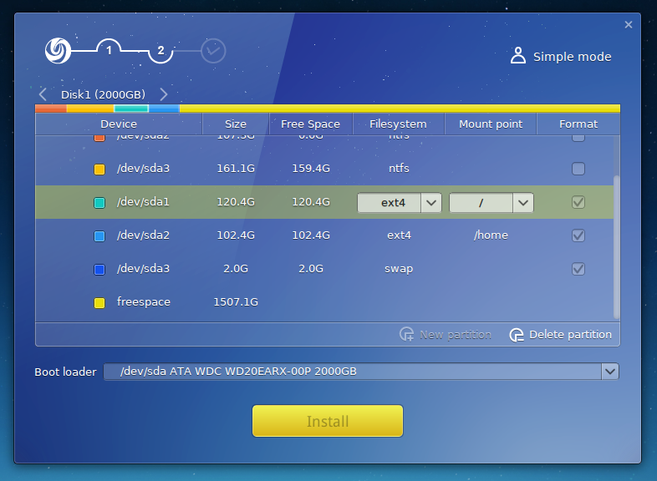

Expert mode needs basic professional knowledge and is not suitable for our common users. The recommended mount ways are as follows:

|  |  |  |  |
| --- | --- | --- | --- |
| Mount Point | Suggest | File System | Size |
| / | only | EXT4（recommended） | More than 10G |
| /home | recommended | EXT4（recommended） | More than 10G |
| Swap | option | No setting | 2G parted for memory less than 4G and not parted for memory over 4G |

Install after selected the needed partition and you can view PPT to know the latest features of deepin OS during automatic instalation. After installed, deepin Installer will prompt to restart instantly or cancel, please choose what you want.

**System Installation**

Original Installation、[Experience Installation](http://wiki.deepin.org/index.php?title=Experience_Installation)  
[Installation Failed](http://wiki.deepin.org/index.php?title=Installation_Failed)、[Fixing Startup](http://wiki.deepin.org/index.php?title=Fixing_Startup)  
[Uninstalling System](http://wiki.deepin.org/index.php?title=Uninstalling_System)